**Python If Else Statements**

**Syntax:**

1. if(condition):  False
2. statements
3. else:   True
4. statements

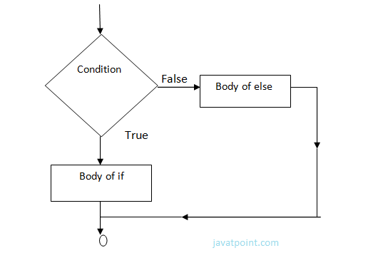

**Example-**

1. year=2000
2. if year%4==0:
3. print  "Year is Leap"
4. else:
5. print "Year is not Leap"

**Output:**

Year is Leap